Pupil Wellbeing Policy

We are continually developing our Wellbeing Promotion Process within the school, which is supported by the Department of Education and the Health Service Executive .We have a duty to provide the best quality and the most appropriate education in order to promote the wellbeing of our students.

Holy Spirit GNS provides support to pupil well being
- Whole School Approach
- Care Team Meetings

Whole School Approach to Well-being
Our whole school approach involves all members of the school community engaging in a collaborative process of change to improve specific area of school life on well-being. By adopting a whole school approach we aim to produce a wide range of educational and social benefits for our pupils, including improved behaviour, increased inclusion, improved learning, greater social cohesion, increased social capital and improvements to mental health. The whole school approach. Students flourish when there is a whole school approach to supporting their growth and where there is a shared belief in their potential for development, learning and well-being. HSGNS is responsible for providing an environment that nurtures and supports students.

Benefits of promoting well-being
By implementing a whole school approach to well-being the benefits include:
- Better learning results for pupils
- Promoting of staff health
- A coordinated approach to social, physical and environmental needs
- Increased pupil self-esteem
- Lowered incidence of bullying
- School environments is safer and more secure
- Better understanding of schools’ health aims
- Improved relationships within the school
- More involvement of parents/guardians
- Better use of outside agencies

Wellbeing Policy Statement and Framework
The Department’s Wellbeing Policy Statement and Framework for Practice assists schools in ensuring that well-being promotion is embedded within the school’s existing practice. The school’s review and development process using the Wellbeing Policy Statement and Framework for Practice provides guidance and practical resources to assist in the further enhancement of whole school approaches to well-being promotion in the area of:
- Culture and environment
- Curriculum
- Policy and planning
- Relationships and partnerships
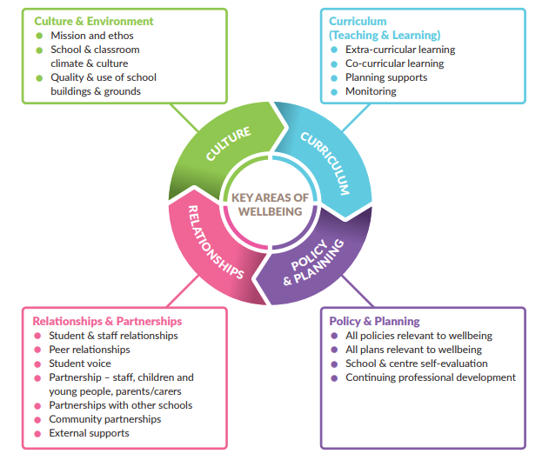

Culture and Environment
HSGNS aims to foster an environment that enhances competence and well-being, one that consciously fosters warm relationships, encourages participation , develops pupil and teacher autonomy and cultivates clarity about boundaries, rules and positive expectations.
We provide a safe, secure and stimulating environment that encourages and supports pupils, staff and members of the whole school community, both in and out of school.
We encourage and promote self-esteem and self-confidence by providing opportunities for all members of the school community to contribute to school life. The school community is encouraged to make healthy choices and to take responsibility for their own health.

Curriculum and Learning
The teaching and learning in HSGNS aims to be inclusive, engaging, differentiated and foster expectations of high achievement and provide opportunity for success. The SPHE curriculum strongly supports the social and emotional well-being of our pupils, by placing an emphasis on children’s social and emotional skills, attitudes, behaviour and therefore learning performance.
In line with best practice the Continuum of Support model delivered within our school and co ordinated by our SENCO and SET team offers a flexible framework within which we can address all educational needs, including well-being needs of our pupils.

Policy and Planning
Policies are written collaboratively and are reviewed regularly, they support the day to day running of the school.

Partnerships
HSGNS continues to develop strong partnerships with parents/guardians and the wider community, which is a central part of the well being process. We efficiently engage with appropriate agencies and specialist services to advise, support and contribute to health and well-being, teaching and learning.

Role of Teachers
It is essential that all staff continue to develop their confidence in the promotion of well-being. The classroom teacher is best placed to work sensitively and consistently with students and she/he can have a powerful impact on influencing a student's attitudes, values and behaviour in all aspects of well-being education. This can be achieved through continual professional development which includes the sharing of expertise and learning and having opportunities to model and engage in collaborative working.

School Based Initiatives that Promote Well Being
We have a number of initiatives that promote well-being throughout the school day:
- Aistear which encompasses four themes: Well being, Identity and Belonging, Communication , Exploring and Thinking. This programme runs from JI to 1st class.
- Project based learning in senior classes
- SPHE: Stay Safe, Walk Tall, RSE
- Friends for Life
- Incredible Years
- Continuum of Support
- Restorative Practice
- Yard time structured play
- Student Council and committees: Active Flag, Green Schools
- Internet Safety workshops
- Wellbeing week
- Partnership with DCU fitness
- GPO Setanta/Ballymun Kickhams
- Healthy Eating Policy
- Swimming
- Weekly assemblies
- Green Card system
- Star of the Week
- Themed weeks
- Promoting the Arts
- After school clubs
- Communicating with NCSE re individual supports for students
- Education Welfare Officer
- Aisling Project
- RECO
- Young Ballymun
- Axis
- Links with HSE personnel
- Play therapists/ School Completion Programme BEST

HDGNS Well- being Protective Factors
In HSGNS well-being protective factors include:
- Positive relationships with peers and teachers-including positive teacher classroom management strategies and a sharing of positive behaviour management practices with parents
- A sense of belonging, security and connectedness to school through a positive school climate and participation in school and community activities
- Opportunities for social and emotional learning including the development of attention and planning, self-awareness, self -management, relationship and responsible decision making skills.
- Fostering expectations, recognising contributions , effort and achievement and providing opportunities for success
- Well being of school personnel
- Protocols and support systems for families should difficulties arise
- Opportunities to develop the skills to cope with using digital technologies in a safe way
- Opportunities to develop skills to manage stress that may be linked to school work

Well-Being Risk Factors
- Disengagement
- Absenteeism
- Relationship difficulties
- Low achievement/ learning difficulties/ emotional and behavioural needs
- Cultural differences
- School transitions
- Poor connection between family and school
- Lack of opportunity to develop coping skills

Supporting Individual Pupils: The Care Team
The Student Support Care Team look after the overall general well being of students. The care team through communication with the class teacher identifies students who have a greater need for a higher level of intervention from the school community. The care team meet weekly to discuss the needs of the pupils in the school as a whole. Children may be identified as needing additional teaching support, emotional support or home support.

Students who experience difficulty in their life can struggle to fully engage in learning. The care team strives to improve the lives of students and ensure their access to the curriculum and learning.

The Care Team undertake the following:
- To liaise with external professionals about the welfare of the child
- To liaise with parents / guardians of the child
- To share information in a confidential manner
- To coordinate a response to the needs of the student
- To review and monitor the students with care needs

The Continuum of Support
The following principles are used by Holy Spirit GNS to guide the implementation of the revised model for allocating special education teaching supports. They form a whole-school approach to provision for pupils with special educational needs in our school. All teachers on the SEN team agree to participate in in class support for pupils .
● Resources provided to support pupils with special educational needs are used to facilitate the development of a truly inclusive model in our school.
● Supports provided to pupils with special educational needs are based on identified needs and are informed by regular reviews of progress (in consultation with parents and pupils) as outlined in the Continuum of Support Guidelines.
● The class teacher has primary responsibility for the progress and care of all pupils in the classroom, including pupils with special educational needs.
● Special education teaching supports provided to our school are used for the support of pupils with identified special educational needs, including those pupils for whom English is an Additional Language (EAL). The special education teaching supports are not used to reduce the pupil-teacher ratio in mainstream classes.
Support teachers will engage with in class support for pupils as far as is practicable to address SEN.
● Pupils with the greatest levels of need will have access to the greatest level of support., and whenever possible, these pupils will be supported by teachers with relevant expertise who can provide continuity of support.
● The school establishes and maintains a core team of teachers to meet the needs of pupils with special educational needs. All teachers members will have access to continuing professional development to support the diverse needs of pupils with special educational needs.

A​ ​three-step​ ​process​ ​to​ ​support​ ​pupils​ ​with​ ​special​ ​educational​ ​needs is in place to guide identification, intervention and monitoring of outcomes for pupils with special educational needs.
Success Criteria
The evaluation of the well-being programme will take places under the School Self Evaluation Model.
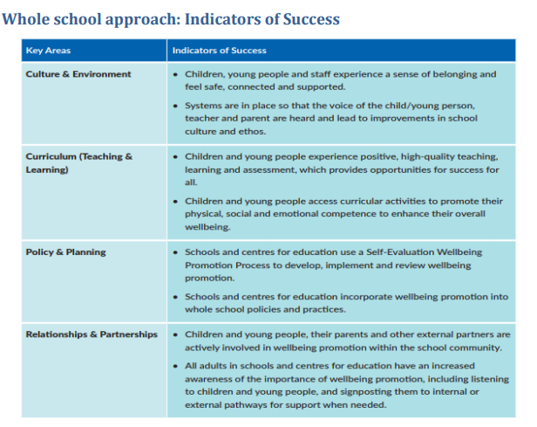

Link with other policies in the School

- Code of behaviour
- Anti Bullying Policy
- Critical Incident Policy
- Admissions Policy
- Special Educational Needs Policy
- RSE policy
- SPHE policy
- Staff Induction
- Staff well-being policy
- Health Promoting School
- Healthy Eating Policy

Ratified on :___________ Signed:___________

Review Date :_________ Chairperson

